Criteria C Development

# Fulfilling Success Criteria

I have achieved all success criteria by creating the application on Adobe Dreamweaver.

# Homepage of the Application

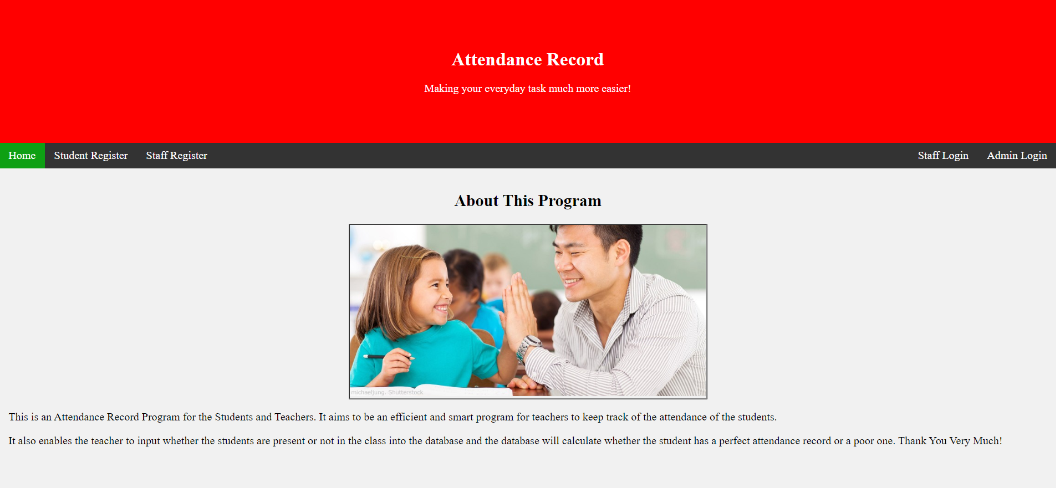

Form for Admin to login

Form for staff to login to the system

Form for Staff to Register

Form for Students to Register

The Homepage of the Application

# Staff Login and Landing Page

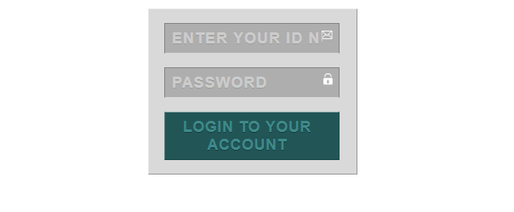

Log In with pre-registered staff ID_Number and Password. These login credentials will be checked with a phpMyAdmin Database.

Textbox to enter Password

Textbox to enter ID_Number

Staff will be directed to the Staff Homepage if the login is successful. Here, they can do so tasks and logout.

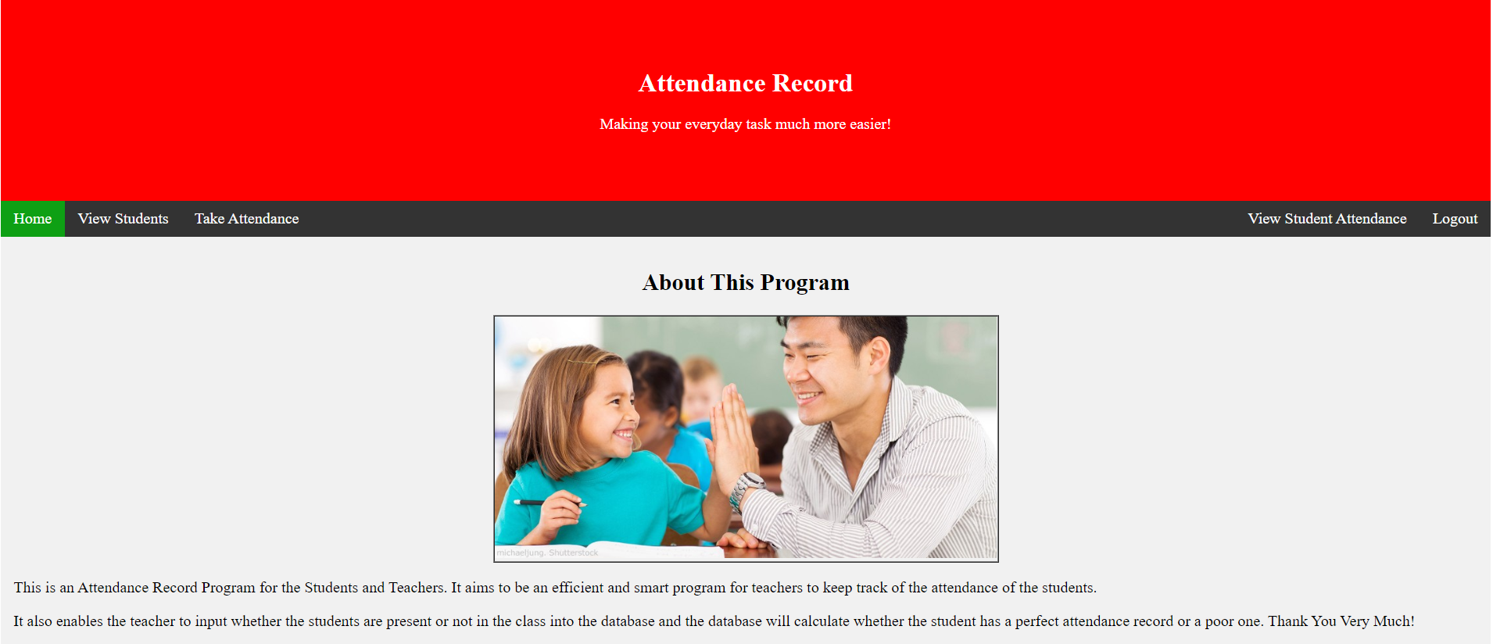

Logout for the staff. Staff will be redirected back to the Staff Login Form

This allows staff to view the student attendance, no. of days they were present, their status, etc

This allows the teacher to take the student attendance

This shows the view form of students where staff can view the students

Redirects to Staff Homepage

# Staff Take Attendance Page

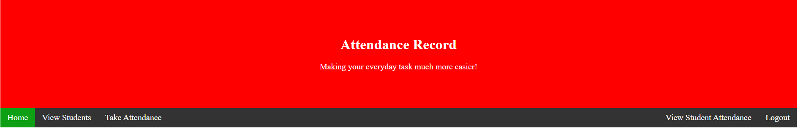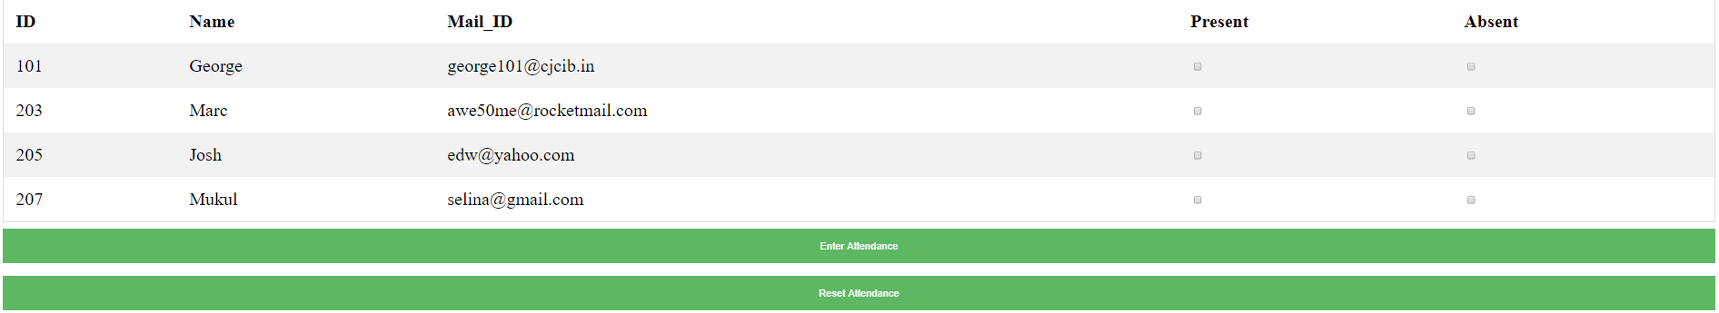

This button enters the information of those present and absent into the database. It will be added to the no. of days present, no. of days absent and total no. of school days.

This button resets all the attendance.

This page displays all the students along with their ID, their name, and email address

Here, staff members can mark whether the students are present or absent.

If the staff member clicks on Take Attendance, this is the page they are directed to. Here Staff Members can take attendance of students.

# View Students and View Student Attendance for Staff

Users are directed to this page if they click on ‘View Students’ on the navbar

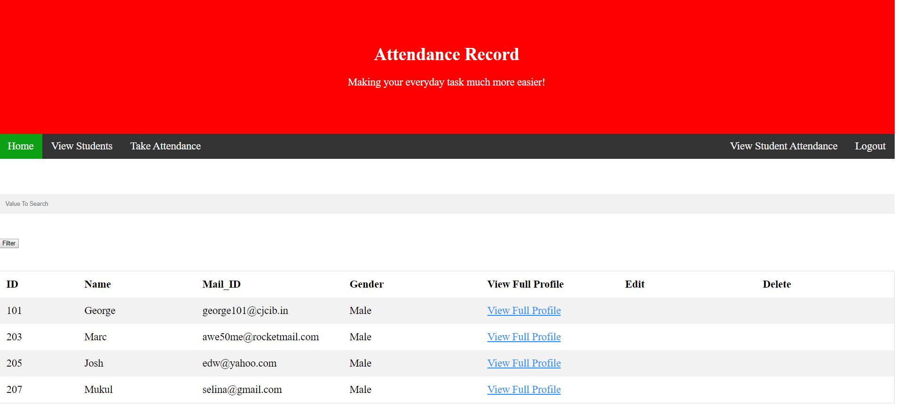

This page displays all the students along with their ID, their name, and email address and gender

This ‘Delete’ link allows you to delete a student’s info from the database

This link allows you to view the student’s full profile

This button filters out all the values that don’t match the criteria in the searchbox

A textbox where you can search a particular student

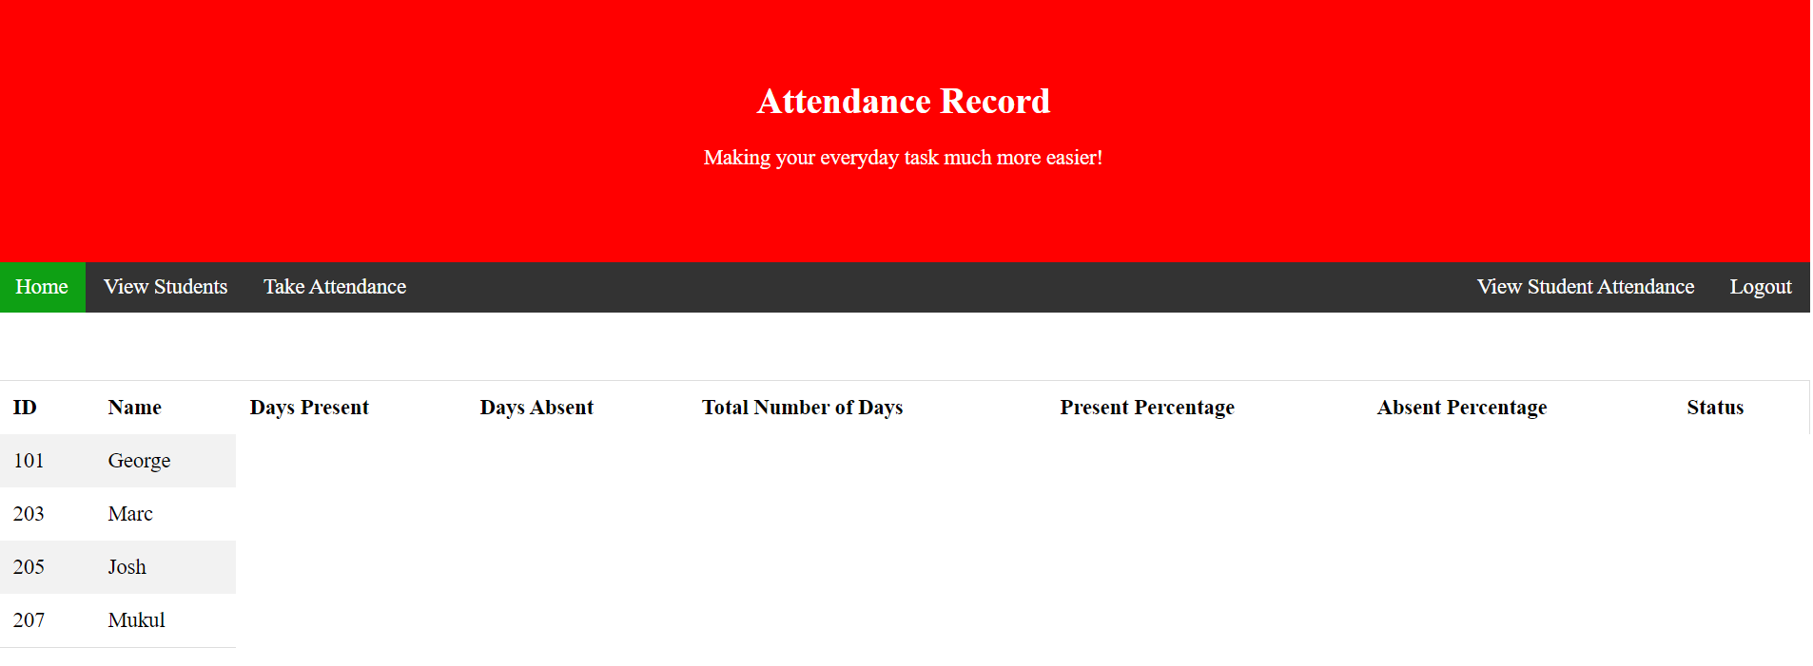

The user is directed to this page if he/she clicks on ‘View Student Attendance’

This page displays all the students along with their information such as ID, Name, Days Present, Days Absent, Total No. of Days, Present Percentage, Absent Percentage, and Status. This information is taken directly out of the database and displayed here.

# Edit Full Profile for Both Staff and Admin

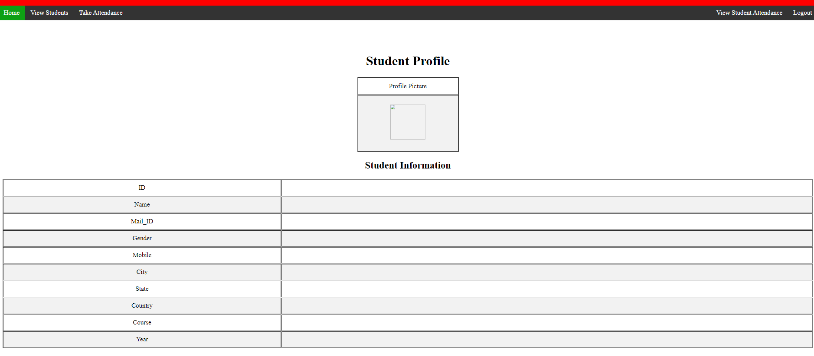

Student’s full information is displayed here like the ID, Name, Mail_ID, Gender, Mobile, City, State, Country, Course and Year

This page is displayed if the user clicks on the ‘View Full Profile’ in the View Students page.

Student’s Profile Picture is displayed here.

# Registration Forms for Both Student and Teacher

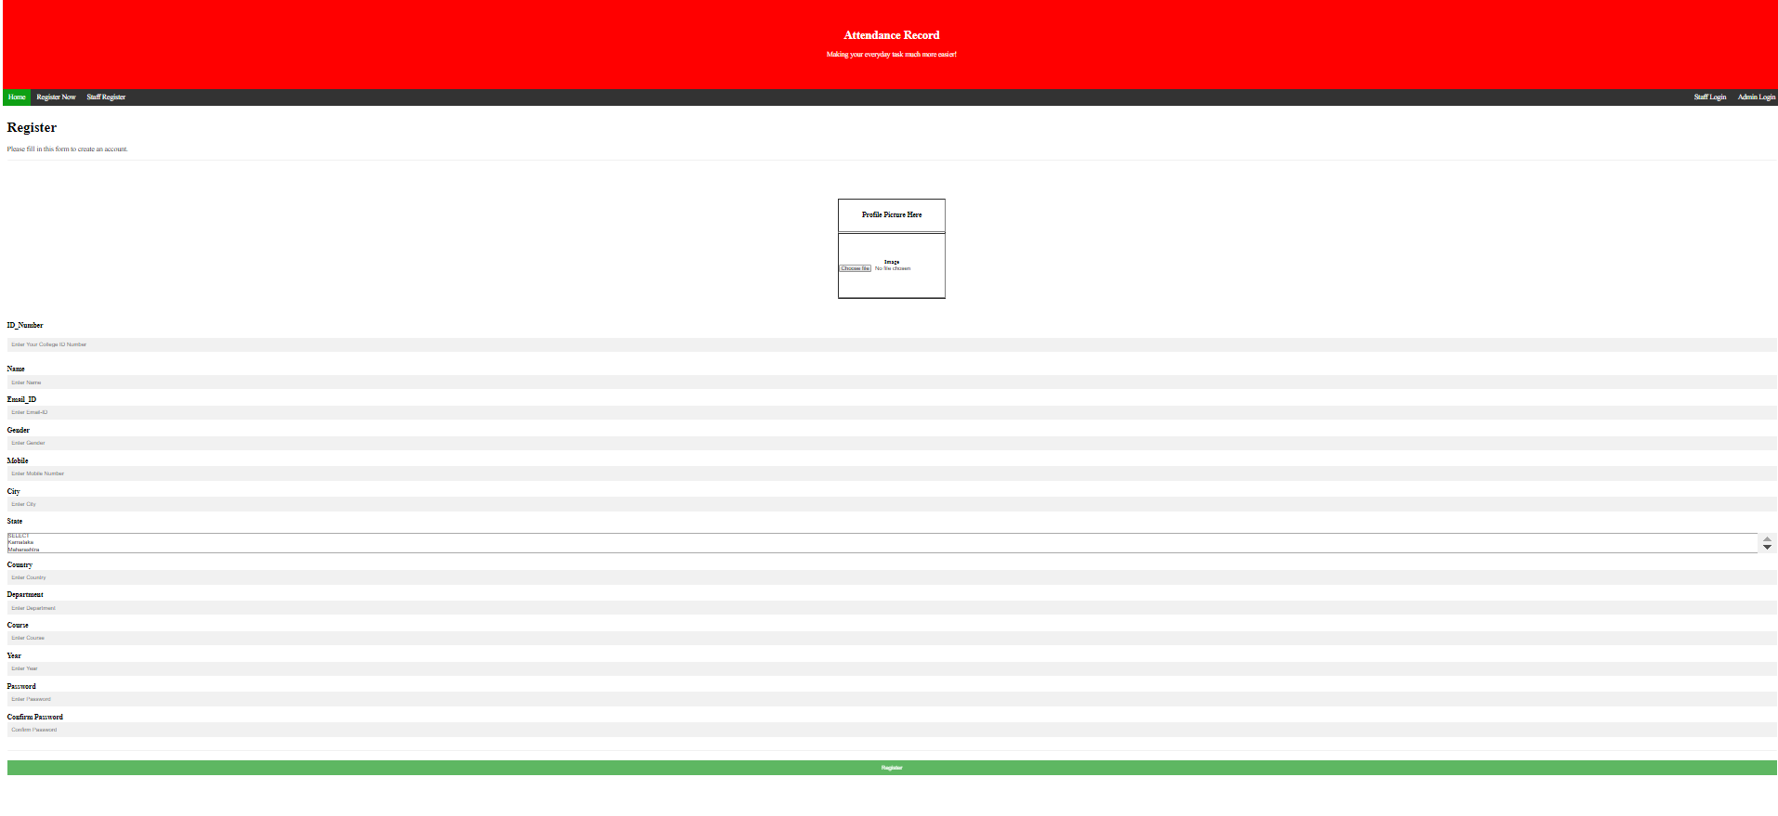

This is where students can save their profile pictures.

This is a registration form for students where the student can enter information into the database.

# Admin Login and Landing Page



Log In with pre-registered staff ID_Number and Password. These login credentials will be checked with a phpMyAdmin Database.

Textbox to enter Password

Textbox to enter ID_Number

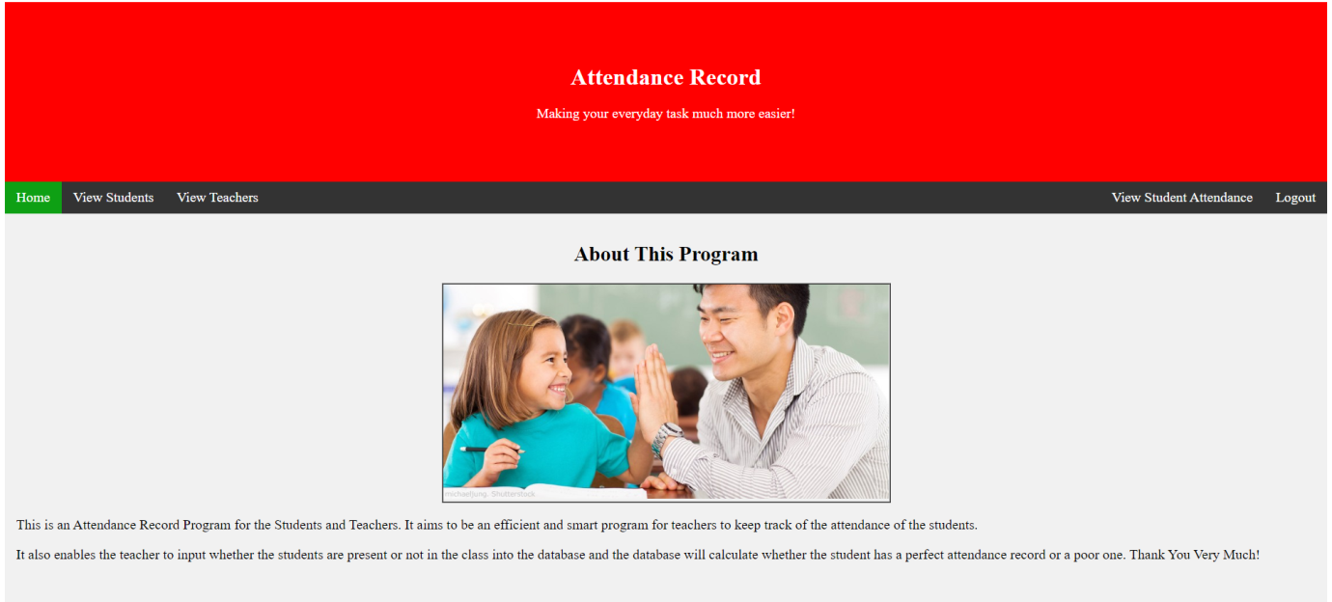

This allows you to view the student attendance

This allows you to view the students info

Staff will be directed to the Staff Homepage if the login is successful. Here, they can do so tasks and logout.

This directs you back to the admin login page

This allows you to view the teachers info

# View Students for Admin

Users are directed to this page if they click on ‘View Students’ on the navbar



This page displays all the students along with their ID, their name, and email address and gender

This ‘Delete’ link allows you to delete a student’s info from the database

This link allows you to view the student’s full profile

This button filters out all the values that don’t match the criteria in the searchbox

A textbox where you can search a particular student

# View Full Profile for Admin



Student’s full information is displayed here like the ID, Name, Mail_ID, Gender, Mobile, City, State, Country, Course and Year

This page is displayed if the user clicks on the ‘View Full Profile’ in the View Students page.

Student’s Profile Picture is displayed here.

# View Teachers for Admin

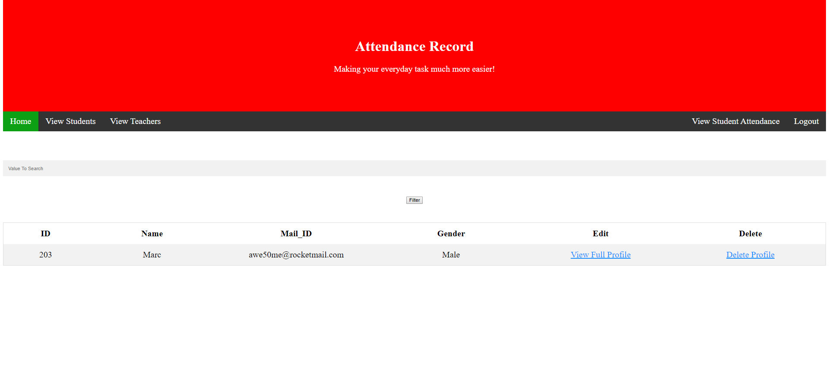

This deletes a teacher’s profile

This enables you to view the full profile of teachers

These are the records taken from the database

This button filters out the data displayed according to how you described the data in the search box

This is where you can type in words describing the info you’re looking for

# View Full Teacher Profile

# View Student Attendance for Admin



The user is directed to this page if he/she clicks on ‘View Student Attendance’

This page displays all the students along with their information such as ID, Name, Days Present, Days Absent, Total No. of Days, Present Percentage, Absent Percentage, and Status. This information is taken directly out of the database and displayed here.